Hounslow Mental Health Support Team (MHST)
Update: 8th June 2020
Who are we?
- The Mental Health Support Teams are part of an exciting trailblazer project funded by NHS England, Health Education England and partners. Our aim is improving the mental health and wellbeing of children and young people in schools.

- We initially worked with 21 primary and secondary schools during our pilot year, and have been expanding since January 2020 to improve access for all schools in the borough. There are 3 Mental Health Support Teams spanning East, West and Central Hounslow, mapped on to the same clusters as the Early Help Hub.

- We are staffed by newly trained Educational Wellbeing Practitioners (EWPs) and trainee Cognitive Behavioural Therapists, who work with young people and the parents of children with anxiety and challenging behaviour. Referrals are received directly through liaison with a link worker in each school.

- Our interventions are preventative, designed to improve early access and early intervention for mental health services in Hounslow. We can also work with staff to support a whole school approach to mental health and wellbeing e.g. through consultations and training sessions for staff.

Updated MHST ways of working
Opening up our Guided Self-Help (GSH) offer  Due to lockdown, referrals to the MHST’S have understandably slowed in some areas, and picked up in others. We need to adjust how we work to ensure that we focus resources where they are needed most; in schools that have potential referrals for the next half term.  To date, our offer has been available to 40 schools. We are now opening up to the remaining schools in the borough. If you have not collaborated with your local MHST yet, please check your inbox for the introductory email we sent on 3rd June 2020. | Your local Educational Wellbeing Practitioner (EWP)  Each school in the borough will soon have a dedicated EWP. For schools who have had an ‘embedded practitioner’ to date, this will likely be the same person – but they will no longer be physically embedded in the school for one morning per week. In schools where this is a new service, EWPs will be in touch to introduce themselves in the coming days.  Your dedicated EWP will your first point of contact for discussing potential referrals, or other support that is available through the MHST. |  | Contact us:  Hounslow East MHST  Team Lead: Shelley Oakeshott  Team Supervisor: Cath Adcock  Email: wlm-tr.hounslowmhsteast@nhs.net  Hounslow Central MHST  Team Lead: Shelley Oakeshott  Team Supervisor: Joanna Penty  Email: wlm-tr.hounslowmhstcentral@nhs.net  Hounslow West MHST  Team Lead: Claire Edwards  Team Supervisor: Claire Edwards  Email: wlm-tr.hounslowmhstwest@nhs.net
The Hounslow MHST Menu
Each half term, we will write to you with an update on our menu of support. Your dedicated EWP will then follow up to see what MHST services you would like to access in the weeks and months ahead.

The services currently being offered will run through the summer and the menu will cover:

Guided self-help (GSH) Currently delivered by video/ telephone only due to COVID- 19
- Referral criteria remain the same - check with your EWP if you’re not sure!
- Link workers refer directly to EWPs

We have adapted GSH in that:
- Referrals are sent electronically or verbally rather than physically (we can talk you through this process)
- Interventions will be by phone or video
- Link worker review meetings with practitioners will be by phone or video
- We have adapted the GSH models to make them
    - Better suited (clinically) to conditions of lock down
    - Easier and safer to deliver by video (in line with West London NHS Trust’s current Information governance policy)
Group-work
- Friends for Life (we are currently only offering universal F4L for returning year 6 students due to Covid 19)
  - A 10 session resilience group (2 sessions per week)
  - Delivered face to face by school staff with year 6 children
  - We provide free resources, training and weekly group support sessions (by video)

- Overcoming your child’s fears and worries (video versions of this anxiety group which will run over the summer due to Covid 19)
  - A 6-week group for parents of children with anxiety
  - Schools advertise the group and signpost their parents
  - Parents self-refer
  - MHST staff deliver the group and measure progress

- Additional groups and workshops
- We are working to understand how the MHSTs can best support schools during this challenging time – do have a chat with your dedicated EWP about your school’s mental health and emotional wellbeing needs, so that this can inform the development of new groups and workshops.
- We are mindful that many children and young people will struggle to transition back to a more normal school life, and that some are likely to need support with this. We will be designing GSH resources for returning to school, and will be in touch shortly about this.
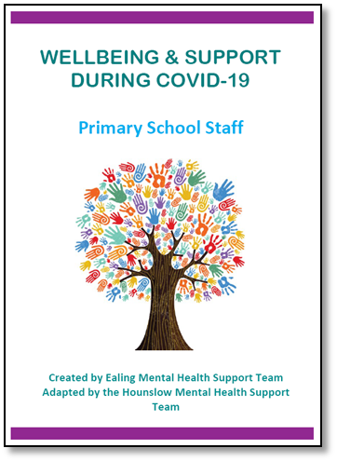
Self–help resources
Hounslow MHST have worked with colleagues in Ealing to develop handbooks of self-help resources for
pupils, parents and staff in Hounslow primary and secondary schools. These have been circulated
through bulletins and our recent emails to all
schools – let your local MHST know if you
have not received them!

Other mental health concerns
If you have any other concerns about mental health and emotional wellbeing in
your school community, please discuss them with your EWP or send an email to your
local MHST to arrange a consultation.

Hounslow East MHST  Email: wlm-tr.hounslowmhsteast@nhs.net |  | Hounslow Central MHST  Email: wlm-tr.hounslowmhstcentral@nhs.net
Hounslow West MHST
Email: wlm-tr.hounslowmhstwest@nhs.net

