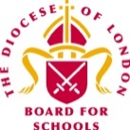


Spring Term 2021!

Dear Colleagues,

Welcome to this first edition of the RE Newsletter for Community Schools for the current term. I am well aware that there have been fresh challenges and uncertainties for all teachers and schools with the new lockdown that is now in place. I know you are working tirelessly to do the very best you can for the children and young people in your care and I am continually inspired by your resilience and strength of spirit! Whether our subject is top of your list at the moment or just one among many other competing priorities, I am still here to offer you help, advice and support with RE (or Collective Worship) in your school. You may be:

- preparing teaching and learning
- reviewing and revising RE documentation such as schemes of learning and policy statements
- organising existing resources and/or selecting new ones
- developing your own subject knowledge.

I would be delighted to hear from you. Do not hesitate to contact me if you would like to make an online or telephone appointment!

Lesley Prior

Adviser for RE in Community Schools

RE IN COMMUNITY SCHOOLS NEWSLETTER
Contact Details: Lesley Prior
Part time Adviser for Religious Education in Community Schools
London Diocesan Board for Schools
36, Causton Street
London
SW1P 4AU

Tel. No: 07808 761 148
lesley.prior@london.anglican.org

- LB Brent: 11th February/11th May  - LB Hammersmith & Fulham/RB Kensington &  Chelsea/City of Westminster: 4th March/10th June  - LB Harrow: 17th June  - LB Hounslow: 25th March/8th June/12th October  - RB Kingston/LB Richmond: 9th February/20th May  These will take place virtually. Please contact me for more details or register online in the usual way. | Dates of Future Primary RE Network Meetings  2021
RE in Lockdown

Spirited Arts Competition 2021

As many of you know, there is a range of material available to enable you to support the teaching of RE at this time, whether for online lessons, independent study or via home learning packs. The BBC has some useful resources but RE is often not strongly represented. See: https://www.bbc.co.uk/bitesize/subjects/zmyb4wx

The Oak National Academy has increased its RE content since last spring, but the focus appears to be very much on factual knowledge with few opportunities for children to be reflective about the big, open questions that lie at the heart of truly effective RE. See: https://teachers.thenational.academy/subjects/religious-education and https://classroom.thenational.academy/assemblies for assembly/CW ideas.

NATRE has done some excellent work in collating suggested materials from teachers around the country and these can be accessed here: https://www.natre.org.uk/about-natre/free-resources-for-you-and-your-pupils/

Please remember to use your professional discernment at all times as the quality of the resources mentioned here can be variable and do contact me if you would like to discuss any concerns or recommend others!

Join hundreds of schools from around the world taking part in this year's Spirited Arts competition! The organisers welcome entries in (almost!) any artform your pupils can think of, including:

- Art (painting, drawing, sketching etc)
- Poetry
- Photography
- Dance
- Music
- Drama
- Sculpture

Winning entries will provide a good response to one of the five themes, and judges will be asking is it original? Is it well-crafted? And (most importantly!) is it excellent RE?

The annual competition starts at the beginning of every school year and runs through the spring and summer terms. All entries must be received before 31st July 2021. To enable teachers to incorporate the art competition into their RE lessons, many schools have an ‘Spirited Arts’ unit, or a special learning RE/arts week. Many schools host their own Spirited Arts event and send their ten winning entries in to this international competition. What a great way to engage all your teachers and pupils and raise the profile of RE in your school! Pupils can enter individually, in pairs or groups, or as whole class, year or school entries. See this link for all the details: https://www.natre.org.uk/about-natre/projects/spirited-arts/spirited-arts-2020/
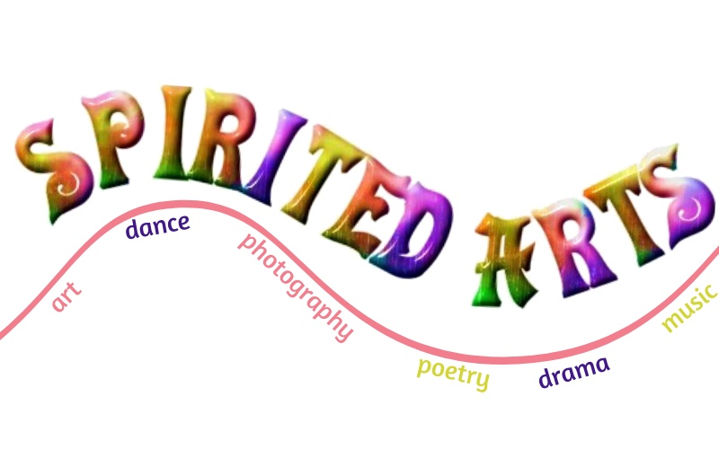

Pupils’ RE Blog Competition!

Why does an Education in Religion and Worldviews (or RE) matter?

Why does our subject matter? Why is it important? Why is it relevant? Why is it engaging?

A new competition is inviting children and young people to write a 500-word blog about why Religion and Worldviews (or RE) matters to them as a school subject. The aim of this competition is to promote the subject and its importance in 21st Century from a child or young person’s point of view. Winning entries will be notified and their blogs posted on the RE:ONLINE website in summer 2021.
It is also hoped that the competition provides an opportunity for pupils to engage with the subject whether learning at home or in school over the coming weeks.

Who Can Enter?
The competition is open to all pupils aged 5-18. Pupils can enter individually or in pairs. Entries are limited to five per school per age group. Schools may want to hold their own internal competition and submit their best selection s to RE:ONLINE.

Prizes And Judging
Judging will be by Culham St Gabriel’s Trustees, staff and consultants and takes place in April 2021.Entries are split into Key Stages (1,2,3,4 and 5) for judging. At least one winner will be chosen from each Key Stage.

Judges will particularly look for:
- Making an original or fresh viewpoint
- A unique or creative writing style
- Supporting argument with examples and illustrations
- Explaining the impact of studying Religion and Worldviews beyond the classroom
- Ability to keep the reader excited and elicit a personal response

Prizes are:
- Individual pupil winners £20 Book Voucher
- Paired pupil winners £10 Book Voucher each
- Each school whose pupil(s) produce winning work will also receive a voucher to spend on RE Resources for their school.

How To Enter
Entries should consist of a maximum of 500 words, plus a title (the question ‘Why does an education in Religion and Worldviews matter?’ can be used as the title) and references if appropriate. Each entry file name should clearly state the name of the pupil, the key stage and school.

Blogs can be word-processed or hand-written. If the blog is hand-written a photograph of the work should be taken, and if appropriate a teacher can transcribe the words underneath for clarity. Shorter blogs from young pupils are welcome.

You should download and complete this form with a list of your entries (maximum five per key stage).
You should then attach this form with up to five entries and submit them via email to competition@cstg.org.uk
All entries must be received by noon on 31st March 2021.

Anti-Racist RE

These project materials are designed to help teachers of RE plan and provide excellent learning in the classroom that encourages pupils to learn about religion and beliefs, racism and prejudice in challenging ways that promote the well-being of all in our richly plural communities.

Project partners without whom this work would not be possible include black, Asian and minority ethnic teachers, academics, religious and non-religious voices from many communities, other subject associations and educational partners and many pupils.

The project is generously supported initially by the Free Churches Group and Methodist Schools, and managed, written and edited by Lat Blaylock, RE Adviser and editor of REtoday magazine.
There is a free a unit of work for the 8-11s in primary schools focusing on two key questions: What can be done to reduce racism? Can religion help?

The unit provides non-statutory exemplification of some good teaching and learning for any school to use. The work is presented as a single unit covering several lessons, but many users may wish to use these anti-racist RE lessons throughout their schemes of learning.

Please see: https://www.natre.org.uk/about-natre/projects/anti-racist-re/

RE Definitions

Some of you will remember the free app called RE Definitions - it disappeared from my mobile ‘phone (and perhaps your too?) some months ago. But the associated website is still active and can be found here:

http://re-definitions.org.uk/

Via this link, you can find key RE vocabulary from a very wide range of belief systems. Each word is explained carefully and concisely and there are little sound clips to help you to pronounce each one correctly. There are also some entries with associated materials provided to help you to learn more about these key terms and how to include them in your teaching and learning programmes!

This online glossary may also be a useful resource for some of your (older and/or more able) pupils too.

Remote Learning in RE:

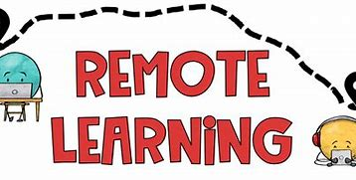

Two key questions to keep in mind when planning for remote learning in RE:

- What are the key learning points you want the children to take away from each session and to be able to remember and reflect upon?
- What are the best teaching strategies to use to enable children to remember the learning and respond to it?

Key principles to keep in mind when planning for remote learning in RE:

- Keep it simple – do not over complicate the learning.
- Keep the sessions short but focused.
- Teach the lesson in context reminding children of the sequence of learning and how the lesson fits into the sequence.
- Focus on quality of input. Make use of high-quality recorded material from you that gives clear well-scripted explanations especially when encountering new material (see links in this newsletter to locate these materials.
- Make good use of recommended video clips.
- Model and scaffold especially if you are sharing a new idea/concept.
- Set achievable tasks that can be completed independently of an adult.
- Provide feedback. This can be done orally when you meet with your pupils.
- Do everything you can to remove any barrier that might prevent a child from accessing the learning.

Remember:
The core purpose of RE is to enable pupils to become religiously educated. Everything we do should link with the overall aims for the subject which include knowledge acquisition but are NOT limited solely to this. What can you provide that will help your pupils continue on this journey?

To note:
Do not overload children with too much information and too many new ideas.

