Back-On-Track
Programme

STUDENT NAME: ____________________________
CENTRE: ____________
YEAR GROUP: _____________________

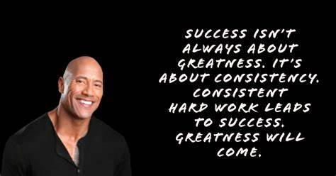

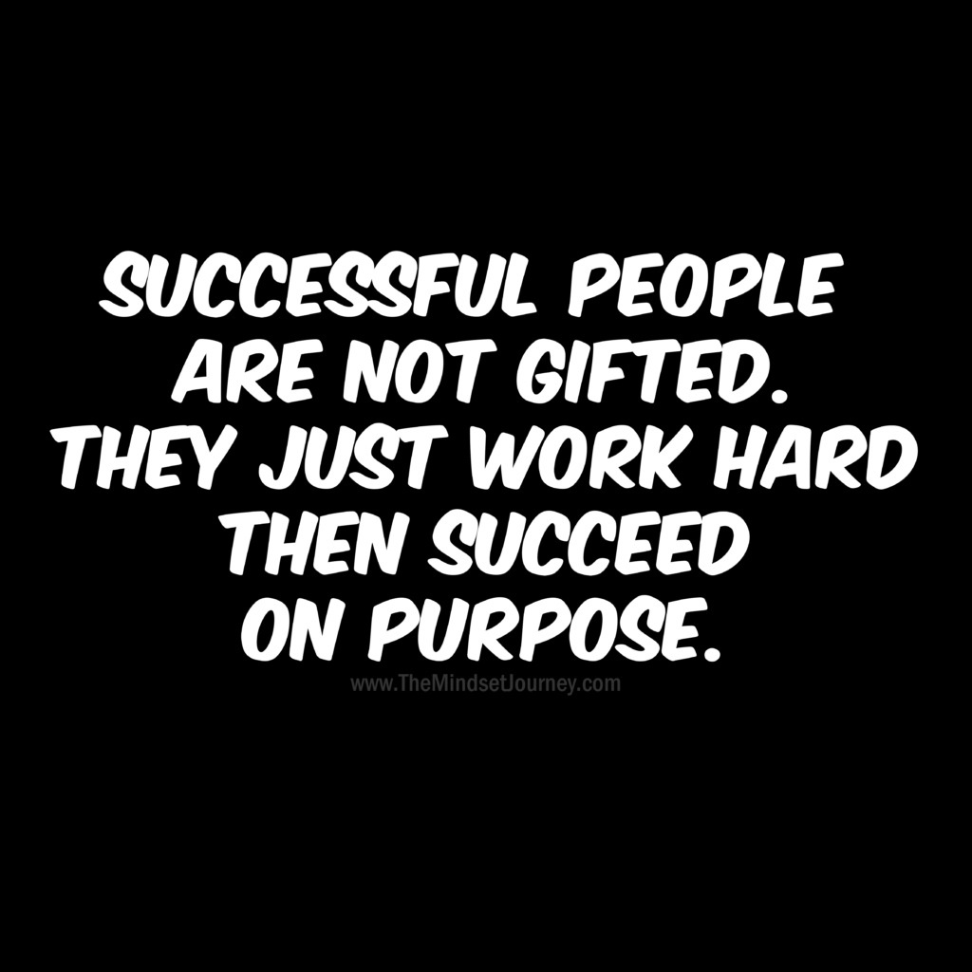

What have I done?
What have I done / been doing? | Who has been affected by this? | How have they been affected? | How do you think this made them feel?
1.

2.

What have I done?
What have I done / been doing? | Who has been affected by this? | How have they been affected? | How do you think this made them feel?
3.

4.

Understanding why I did these things
Look at what you did in the chart above.
Try to think why you might have done these things.
What have I done / been doing? | How was I feeling before I did this? | Did someone say or do something before that upset you or made you think of doing this? | How did I feel after I did this?
1.

2.

Understanding why I did these things
Look at what you did in the chart above.
Try to think why you might have done these things.
What have I done / been doing? | How was I feeling before I did this? | Did someone say or do something before that upset you or made you think of doing this? | How did I feel after I did this?
3.

4.

How am I going to put this right?
What am I going to do to make up for what I have done and to put it right?

Write an apology letter for the people affected here:
Stopping it from happening again
What am I going to do to try to make sure these things do not happen again?
ACTION TO TAKE IN THE SAME SITUATION
1
2
3
4
5

Next time I will do things differently and here is how:
Understanding what I need to do to be successful
Please read below with your Key Worker and tick to acknowledge that you understand and accept the expectations on you.

For it to work out for you at Woodbridge Park, we need you to:
Expectation | I accept this | I don’t accept this
To wear plain black trousers, a plain black top, black socks, black shoes and a white shirt / polo shirt

To hand in my phone, personal electronic devices, any smoking materials as I enter school first thing in the morning

To turn up to school every day and on time. This is 9am, Bridge, 9.15am KS3 and 9.45am KS4

To keep your cool when under pressure – breathe in at least 3 times before reacting to anything

Ask adults for a meeting when you have tensions with other children or staff

To follow my timetable and find an adult to talk to if there is a problem with this

To keep my hands, feet and unkind words to myself

To avoid posting unkind comments or images on social media

End of first week review by key worker:
Statement | YES | NO
I recommend that the pupil is ready to re-integrate back into their centre
I recommend that the pupil requires a second week on the Back-on-track programme

Commentary to support re-integration back into centre at end of Back-on-track:
Has the pupil shown an understanding of the impact of their behaviour?
Has the pupil been calm and settled?
Has the pupil been in every day, on time? Been engaged?

