How to look after my mental health

Name:_____________________________________________
Centre:____________________________________________
Year:______________________________________________
Class:_____________________________________________
CONTENTS

Pre Questionnaire
Section 1: What is good mental health?
Section 2: General tips for looking after your mental health
Section 3: Being in the present – Mindfulness and Relaxation
Section 4: Where to get support
Post Questionnaire
Appendix 1: Fact or fiction templates to cut out
Fact or fiction points for discussion
Appendix 2: Sleep Hygiene information sheet

Pre Questionnaire
Please read each item and circle the response that most applies to you over the past 2 weeks
 |  | All/most of the time | About half of the time | Occasionally | Never
1 | I have felt happy
2 | I have felt calm and relaxed
3 | I have had good energy levels
4 | I have been physically active
5 | I have slept well
6 | I have woken up feeling refreshed and ready for the day
7 | I do things that interest me every day
8 | I do things that I enjoy every day
9 | I have tried to make myself feel better by talking to someone
10 | I try to make myself feel better by looking after myself
11 | I have spent time with friends or family
12 | I have eaten a balanced, healthy diet
13 | I have asked for help when I’ve felt I needed it
What do you hope to get out of this intervention?

SESSION 1 - WHAT IS GOOD MENTAL HEALTH?
Mental health is about the way we think and feel, and the way we respond to things that happen in life. Being mentally healthy doesn’t mean that you are happy all the time, or that you don’t have any problems. Good mental health is about…

- having the skills to manage when things are challenging
- about being able to cope with the ups and downs of life
- about being able to make the most of your potential
- about being able to play a meaningful part in life – with friends, at school and with your family
There is a lot of unnecessary stigma and false information about mental health.

Appendix 1 contains some statements.
Cut them out, and separate them in to what you think are true or false.
Discuss your findings.

Some people use different terms to refer to mental health, such as “emotional health”, “emotional wellbeing”, “mental wellbeing”.
Regardless of the term we use, mental health applies to all of us, just as physical health does. We all have times when we feel down, stressed or frightened. Most of the time these feelings pass quite quickly, but sometimes they stay with us for longer or cause us more of a problem. Everyone is different. Someone might bounce back from a setback quickly, whilst someone else might find it harder to recover from. Our own response to mental health problems can also be different at different times, depending on what else is going on in life. For example: we know that it is ok to feel anxious before a test and therefore normally not be too affected by it, but if we are also struggling with a broken ankle, poor sleep and moving house we may find it more difficult to manage. The emotion we experience may also be more intense.

Choose 2 emotions and brainstorm as many similar words as possible.
Then place some of the words in order of how you perceive their intensity.
This is your opinion – there is no right or wrong.

Example: Happy

Glad  cheerful  happy  joyful  delighted  ecstatic

In the next session, we will look at some of the more general tips that can support us to have good mental health. Prior to the session, use the space below to jot down things that you do during the week that you feel help you look after your mental health, eg chatted to friends, went for a walk.

This week I…..

SESSION 2 – GENERAL TIPS FOR MAINTAINING GOOD MENTAL HEALTH

Share some of the activities that you did during the last week that you feel helped you maintain good mental health. Why do you think it helped? How did it make you feel? Do some things help more than others?

In this session, we’ll focus on some of the more general tips that can help to maintain good mental health. As you work through, use the space provided to make notes:

KEEP PHYSICALLY ACTIVE 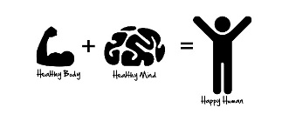
As we saw in the last session, exercise is really beneficial to our mental and physical health. It has been shown to lower anxiety, improve mood, boost self esteem and confidence, help you sleep better, can lead to healthier choices (food, drink etc) and improve concentration and cognitive functioning. Exercise doesn’t have to mean a sport or going to the gym. Gardening, walking, cycling and dancing are all exercise too! Be active outside and get your healthy fix of fresh air and daylight ; do it with friends and get your healthy fix of socialising ; do something you enjoy and get your fix of fun too! Build it in to your daily life as part of a routine and you are more likely to keep it up. For more info, check out:
www.mentalhealth.org.uk/publications/how-to-using-exercise
yoga for teens: www.youtube.com/watch?v=7kgZnJqzNaU
Joe Wicks’ youtube channel: Bodycoach TV has a variety of short PE sessions that you can do at home

What physical activity do you regularly do?

GET GOOD SLEEP 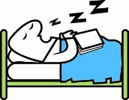
Sleep is really important for both our physical and mental health. Sleep helps to regulate chemicals in our brain, which in turn is important in helping manage our mood and emotions. Developing a healthy sleep routine and sticking to it can enable good quality sleep and be really beneficial.
Describe your current sleep routine? Think about what you do in the hour before bed, what you do when you go to bed, what time you go to bed and get up.

Now look at Appendix 2 and compare your answers to the healthy sleep routine tips

For more info, check out:
www.sleepfoundation.org/articles/healthy-sleep-tips
www.nhs.uk/oneyou/every-mind-matters/sleep/
https://hycscounselling.co.uk/self-help-hub/sleep-matters/
DIET
What we eat and drink affects both our physical and mental health. Having a balanced diet can have a positive impact on our energy levels, can help us think more clearly and can improve our mood and overall sense of wellbeing. Our brain needs a mix of healthy nutrients as much as our body does – a lack of certain nutrients (eg iron, vitamin B12) has been shown to contribute to low mood. Drinks high in caffeine or sugar may provide an immediate “fix” to feeling tired for example, however they are very short lived, can increase other emotions such as anxiety and anger, and can actually impair concentration.

Describe a typical days diet for you (food and drink)

A healthy balanced diet should include:
Lots of different types of fruit and vegetables
Wholegrain cereals or bread
Nuts and seeds
Dairy products
Oily fish
Plenty of water
NB - If you follow a diet that prevents any of these (eg a vegan, or nut free diet) you need to ensure that you are getting the benefits of the food group elsewhere.

Use this list to review your typical diet:
Lots of different types of fruit and vegetables

Wholegrain cereals or bread

Nuts and seeds

Dairy products

Oily fish

Plenty of water

What do you notice?
What would be a “quick win” change that you could change straight away?

For more info, check out:
https://hycscounselling.co.uk/self-help-hub/food-mood/
www.nhs.uk/live-well/eat-well/the-eatwell-guide

TAKE BREAKS, AND DO THINGS YOU ENJOY
A change of scenery, change of pace or change of focus/activity can be really beneficial to our sense of wellbeing. Building time for yourself into your daily routines ensures you prioritise looking after yourself, and can give you crucial “de-stress” time. Doing things we enjoy can boost our self esteem, provide us with “feel good” experiences, give us a sense of achievement and enjoyment, help us connect with people and give us a “break” from difficult or challenging times.

List and discuss things that you can do to take a healthy break in school

List and discuss things that you can do in general that you enjoy

STAY CONNECTED
Spending quality time being in contact with friends or family is really important for our mental health. Being part of a healthy, trusting relationship can help reduce isolation, boost self esteem, reduce anxiety, provide a space to talk safely about our feelings and concerns, provide opportunities to be active and have fun, enable us to feel cared for and for us to care for someone else….the list goes on! Nowadays there are a range of ways for us to stay in touch with people, each with advantages and disadvantages. We need to ensure that our communications are healthy, balanced, meaningful and supportive.

What are some ways of staying in touch with people?
List some possible advantages and disadvantages of each.
Highlight your preference/s
TYPE OF COMMUNICATION | ADVANTAGES | DISADVANTAGES

TALK!
Talking about our feelings ca n help us stay in good mental health and deal with times when we feel troubled. Talking about our worries is NOT a weakness – in fact it is the complete opposite. Taking charge of your health is a strength to be proud of, and by working through this booklet you are taking charge – congratulate yourself. You talking, might even help someone else start to talk themselves. Ask for help when you feel you need it.

Talking to someone we trust can help free up space in your head that is otherwise filled with worrying. It can help you feel listened to and understood. It might not give you immediate solutions but it can help you feel more in control, to see hope in finding solutions or acceptance and to feel supported during difficult times. It’s not always easy to start a conversation, especially if it’s not something you’re used to doing. Take your time, expect it to be a bit clumsy at first, use opportunities as they arise – some people find it easier to have these kind of conversations whilst they are doing something else, such as going for a walk. Sometimes we might feel we don’t know the words to use to describe how we are feeling when we are troubled. To help, try and describe how you are feeling inside your head or inside your body, what does it make you feel like doing? Remember, there are no real rights or wrongs – it is about you and how you are thinking and feeling.
Use the template to write down how you feel emotions in your body, eg head feels very busy and confused, tummy feels like butterflies. Use different colours for different emotions, eg red for anger, green for happy, blue for sad. Notice the different ways and places in which we feel our emotions

Some people prefer to talk to someone who is not their family or friends. School can provide you with opportunities to talk safely to adults, or you could use a service such as Hounslow Youth Counselling Service. This is a free, self referral counselling service for young people in Hounslow – see https://hycscounselling.co.uk/ for more information.

OPTIONAL TASK
Visit the following website to watch videos to support some of the above tips, including:
Sleep
Social connections
Healthy lifestyle
Keeping learning/doing something you enjoy
https://www.nhs.uk/oneyou/every-mind-matters/top-tips-to-improve-your-mental-wellbeing/

Thinking of all the general tips we have looked at, are there any changes you want to make? If so, note them here with the reasons why, and use this during the week to motivate you. Keep a record of how you are doing

SESSION 3 – MINDFULNESS, RELAXATION AND BREATHING
Practising mindfulness, breathing and relaxation regularly can bring great benefits to our mental health and overall sense of wellbeing. In simple terms, being mindful means being aware in the moment – physically, emotionally, mentally, and of the environment, whereas being relaxed means being free of tension. Effective breathing can support both.

So, what it mindfulness?
Mindfulness is a way of paying attention to the present moment, using techniques like meditation and breathing exercises. It helps us become more aware of our thoughts and feelings so that, instead of being overwhelmed by them, we’re better able to manage them.
We tend to be so busy rushing around in life that it is easy to forget to notice what is going on around us or within us. We end up “living in our heads” – being caught up with our thoughts rather than noticing how these thoughts can influence how we feel and how we behave. Changing the way we relate to experiences can enable us to positively change the way we see ourselves and our lives. It can help us notice when our thoughts are taking over.
It can help us reconnect with the body and the sensations we experience, by paying more attention to our senses in the moment.
Get up and walk around the room slowly counting to 5.
Stop and stand still.
Name:
5 things you can see
4 things you can touch or feel
3 things you can hear
2 things you can smell
1 thing you can taste

How to be more mindful
Take time to notice your thoughts, feelings, bodily sensations and the world around you. When you are starting out, it might be helpful to pick a particular time of day or a particular activity where you can be more mindful. Try something new, or doing something familiar but in a different way as your senses will be more alert to the differences. Notice your thoughts – don’t stress about them or try to make them go away – look for acceptance of them, look for connections between them and how they are making you feel or behave. Some people find it helpful to name the thought or feeling, eg this is anxiety.
Mindfulness can be practised in everyday life, as well as in more formal ways. The Mental Health Foundation have created a list of Mindfulness Activities that can be carried out in as little as one minute! 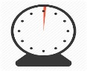
https://www.mentalhealth.org.uk/publications/how-look-after-your-mental-health-using-mindfulness

Research each of these and write a brief description of them
Mindful walking
Mindful eating
Mindful colouring
Mindful listening
Mindful body scanning/body awareness
Mindful meditation
Mindful breathing

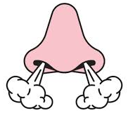
Breathing is an incredibly powerful tool that we all have at our fingertips, yet very few of us are even aware of ourselves breathing, or of changes to our breath if we are feeling troubled.
Watch the video “Mindful Breathing” and complete the exercise
https://www.nhs.uk/oneyou/every-mind-matters/top-tips-to-improve-your-mental-wellbeing/
Make some notes about how you feel now? How does it feel different before and after?

There are a range of breathing techniques that we can use when we are feeling troubled. If you can make your out breath longer than the in breath (rectangular breathing) you can reduce your stress systems being activated; square or star breathing (where the in and out breath are the same) can lower stress levels and take your mind away from your thoughts. Think about what is in the classroom that can help you with these – eg the whiteboard, a square window. Remember to fill the whole of your lung space when you breathe – allow the diaphragm to work – keep the shoulders still. Practise the techniques on the next page and share your thoughts – which do you prefer? What did you find difficult? What effects did you notice?
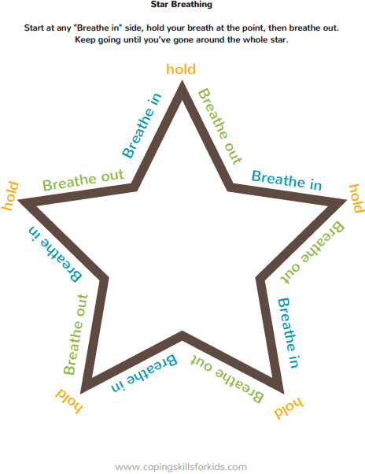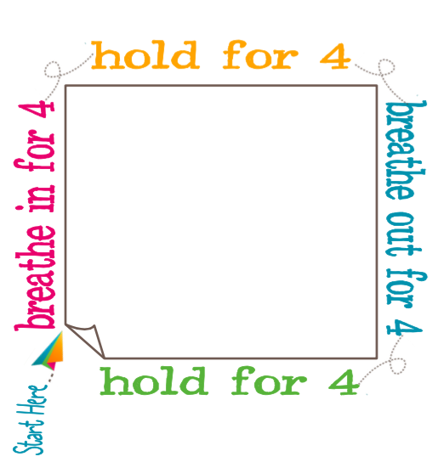
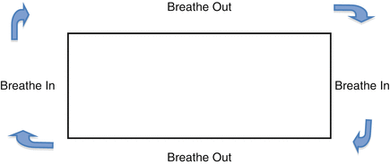

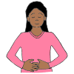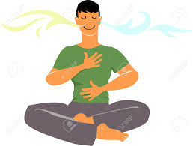
Watch or feel your fingers separate Hand on the belly moves first
as you breathe in and out then the hand on the chest

Relaxation
As with mindfulness and breathing, there are a range of ways to carry out relaxation practices, so it is important to spend time trying them to find out what works and what doesn’t.
Two of the most common practices are Progressive Muscle and Visualisation. Progressive muscle relaxation involves consciously tensing and then relaxing the muscles of the body, training your body to recognise how and where you hold tension and how to relax the muscles.
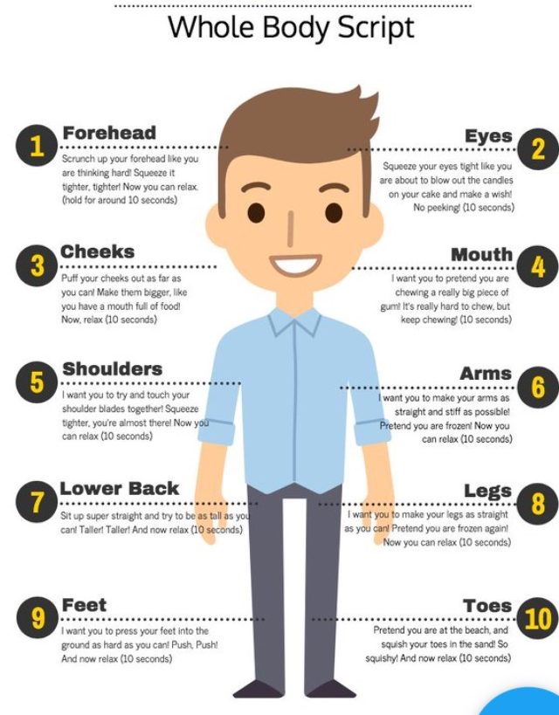
Visualisation uses mental imagery to relax the mind. They usually involve guided scripts to help you imagine a safe, special place for you where you can feel calm and relaxed.
Audio files of a range of relaxation techniques, including progressive muscle, visualisation and mindful breathing can be found at
www.cntw.nhs.uk/resource-library/relaxation-techniques

There are also a wealth of resources on the web, or apps. Visit

https://www.hycscounselling.co.uk/self-help-hub/the-app-zone/
https://www.nhs.uk/apps-library/filter/?categories=Mental%20health
https://www.annafreud.org/on-my-mind/self-care/apps-delivering-self-help-strategies/

Over the next 7 days, try to practise at least 1 mindful/relaxation/breathing activity a day. Make a note of the activity and your thoughts below.
 | Activity | Reflections
Day 1
Day 2
Day 3
Day 4
Day 5
Day 6
Day 7

SESSION 4 – WHAT NOW?
Share your mindful diary from the past 7 days. What activities did you choose and why? How did you get on with them? Did you prefer some over others? Did you notice any benefits?

Think back to all the topics we have covered.

- Physical Activity
- Sleep
- Diet
- Doing enjoyable things
- Staying connected
- Talking about feelings and emotions
- Mindful activities
- Breathing exercises
- Relaxation

Share your reflections on how you think they apply to you.
What changes have you made? What benefits have you noticed? What are you going to keep up? What support do you need to keep you motivated?

Research a few of the places in which we can continue to seek support – add in a summary of what each provides, and add in your own.
Source of support | Nature of support/What is available
School

Family/friends

Hounslow Youth Counselling Service
CAMHS
Headspace.com
On My Mind
Annafreud.org
Young Minds

Use this page to make notes, or write down other ideas/places that you come across for support

Post Questionnaire
Please read each item and circle the response that most applies to you over the past 2 weeks
 |  | All/most of the time | About half of the time | Occasionally | Never
1 | I have felt happy
2 | I have felt calm and relaxed
3 | I have had good energy levels
4 | I have been physically active
5 | I have slept well
6 | I have woken up feeling refreshed and ready for the day
7 | I do things that interest me every day
8 | I do things that I enjoy every day
9 | I have tried to make myself feel better by talking to someone
10 | I try to make myself feel better by looking after myself
11 | I have spent time with friends or family
12 | I have eaten a balanced, healthy diet
13 | I have asked for help when I’ve felt I needed it
Look back at what you hoped to get out of this intervention? Did you this happen? If not, why not?

Appendix 1 – Fact or Fiction templates to cut out

Mental health problems won’t apply to me | Someone with a mental health problem has a mental illness | Getting help early promotes good development of coping skills and recovery
I should avoid someone who has mental health problems and let them get professional help | People with mental health problems are violent and unpredictable | The Equality Act 2010 makes it illegal to discriminate against someone with a mental health problem
Someone with a mental illness will never be able to work | Some risk factors can make people more prone to mental health problems | Exercise can be as effective as medication for mild/moderate depression

Appendix 1 – Fact or fiction points for discussion
Mental health problems won’t apply to me  FALSE - Statistics vary, but it is thought that 1 in 4 or 5 adolescents experience mental health problems and 1 in 7 reach threshold for a diagnosis. Girls and boys are equally prevalent but the nature differs | Someone with poor mental health has a mental illness  FALSE - We all have mental health; it can be good or poor, a person can have good mental health but still have a diagnosed mental illness – it just means they are managing well. Equally a person without a diagnosable mental illness can have poor mental health, meaning they are struggling to cope with things | Getting help early promotes good development of coping skills and recovery  TRUE – evidence shows that early intervention for young people is beneficial for engagement with services, response to treatment, development of coping skills, remaining in school, improved mental health and physical outcomes, reduces isolation, reduces family pressures and many more factors
I should avoid someone who has mental health problems and let them get professional help  FALSE – avoiding someone can increase their sense of isolation and difficulty. Being there for someone who is struggling, being able to listen, being patient, being non judgemental and supportive can be a lifeline. You may need to encourage them to seek professional support where it is needed – you can not take on this responsibility, but you can support | People with mental health problems are violent and unpredictable  FALSE – Most people with a mental health problem are not violent. People with severe mental illness are over 10 x more likely to be the victim of violence as opposed to being the perpetrator, and are more at risk of hurting themselves than hurting others | The Equality Act 2010 makes it illegal to discriminate against someone with a mental health problem  TRUE – it is illegal to discriminate directly or indirectly against someone with a mental health problem, however many people still report feeling discriminated against, particularly due to the negative and incorrect images and stigma surrounding mental health
Someone with a mental illness will never be able to work  FALSE – people with mental health problems can be just as productive as other employees, and can bring many positive character attributes to a workforce, such as empathy, tolerance and understanding as well as work based skills | Some factors can help to protect people more from mental health problems  TRUE – certain factors can help. In school, these include: Experiences of success and achievement, Good overall physical health; Confidence and high self-esteem; Supportive adult relationships; Resilience; Engaged parent/carers; Clear and consistent boundaries; Healthy relationships; Supportive friendship groups; Long term career goals | Exercise can be as effective as medication for mild/moderate depression  TRUE – exercise has been shown to reduce anxiety, improve mood, improve sleep, improve cognitive functioning, improve confidence and self esteem and the evidence shows it to be as effective as medication. Many GP’s now offer exercise referrals prior to considering medication

Appendix 2 - Sleep Hygiene
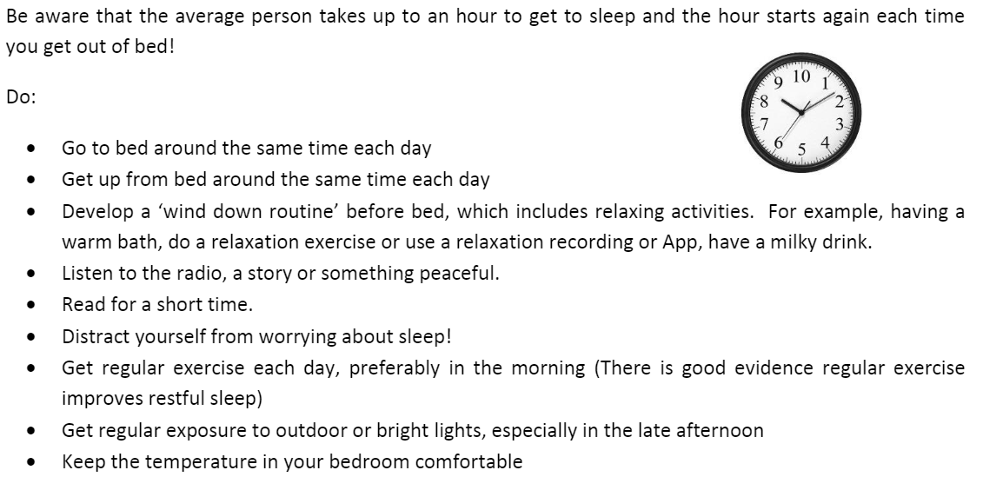
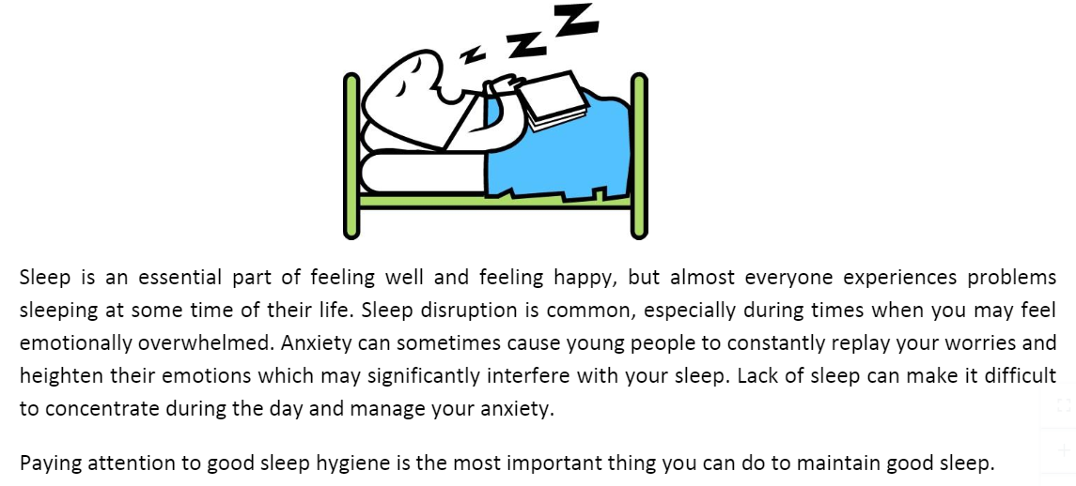
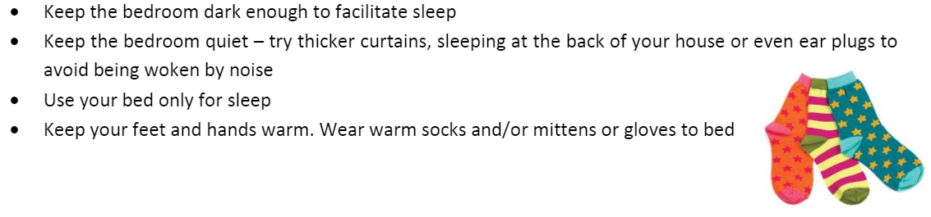
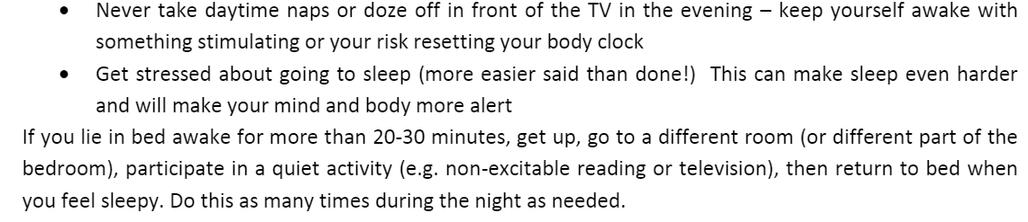
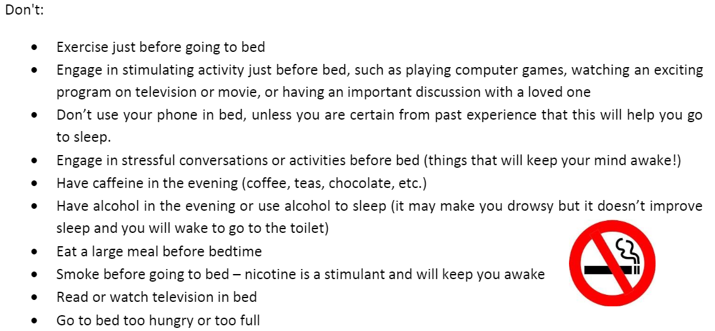

Handout developed by Tower Hamlets CWP Service: Information combined from C&I Depression and Low Mood GSH book, Depression Moodjuice Self-help Guide and Get self-help website – Depression

