Restorative Practice across WPES

A support manual for all service staff on the expected management of restorative practice

Contents

Purpose of the guide | 2
What is Restorative Practice? | 2
Restorative approach | 4
Whole school approach WPES way | 5
Guide to Restorative Practice | 6
Resources | 9-24

Purpose of guide

This guide provides give a clear steer to all relevant service staff on the expectations in relation to the management of restorative practice across WPES.

WPES is a service with several provisions and centres. WPES has an obligation to ensure equality of opportunity and equity in relation to the use of resources and securing consistent high quality provision across all WPES settings.

In essence, this guide exists, to:

- Ensure that all learners get the same entitlement to consistent, high-quality provision across all WPES settings
- Provide clarity to service staff on expectations
- Ensure that restorative practice is robust, purposeful and impactful
- Ensure that there is appropriate follow-up to incidents that merit a restorative response
- Provide an evidence-based track- record of success with the use of restorative practice.

What is Restorative Practice?

Restoritive Justice is a theory of justice that focuses on mediation and agreement rather than punishment. Offenders must accept responsibility for harm and with victims.
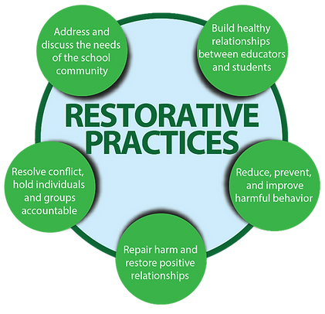

What is it all about?
It is about finding out what people can do and working with them to build on that. It does not mean that those supporting children and families should be stepping in to take control. Evidence shows that the futures of children and their families are brighter when those who support them work with and alongside them instead of making decisions for them or doing things to them.
It describes a way of being which threads through everything we do when we are communicating and resolving difficulties. Restorative approaches support those who work with children and families to focus on building relationships that create change. It is worth bearing in mind that creating change sometimes needs people to be challenged as well as supported.

Who should be using it?

A restorative approach in schools helps develop a healthier learning environment, where children and young people take responsibility over their own behaviour and learning. The minds of those in a restorative school is focused on strengthening and
Repairing relationships, inquisitive about what needs to happen and avoid attributing blame.

When embedded across the whole school, restorative approaches can:
- Develop emotional literacy
- Develop a sense of responsibility and empathy
- Create a more positive learning environment with better attendance
- Fewer behaviour incidents
- Raise children and young people’s awareness of the impact their choices have on others.

Through developing a school ethos based on needs and values, we can avoid assigning blame and punishment by creating an environment where children involved in conflict can reflect, repair and avoid repetition of the same behaviours. The focus of restorative practice is on relationships and it is just as important to use restorative principles and behaviours in the work place as well as with children and families.

Restorative Approaches
There are different restorative approaches and these range from formal to informal processes. No matter what approach is taken, all focus on removing barriers and encouraging a sense of community. Understanding and strengthening relationships with children, young people and families can empower them to share responsibility and bring about positive change in their own lives.
Restorative approaches are built on values, which separate the person from the behaviour. They promote accountability and seek to repair any harm caused in a situation. Restorative approaches may be formal or informal and is based on:
- Respect for one another
- Acknowledging that each person has an opinion that is unique but still of value
- Taking responsibility for your own actions
- Developing skills to solve problems and repair harm.

Why use a restorative approach

Many schools are turning to restorative approaches to create a positive learning environment where pupils have the necessary skills to self regulate their behaviour and learning. Restorative practice is most effective when implemented as a whole school approach by aiming to:
- Develop emotional literacy, truth telling, accountability, responsibility.
- Improve behaviour, attendance, learning environment, and teaching.
- Increase empathy, happiness and social and communication skills.
- Reduce bullying, exclusions, conflict, need for sanctions.

Some of the long-term benefits of a restorative approach are:
- Recognition
- Victimisation/impaction
- Empathy
- Respect
- Positive processing
- Pro-social relationship building
- Boundary setting
- Problem solving
- Appropriate reintegration

WPES and Restorative Practices

At WPES, we value working together, positive relationships, effort and similarities and differences. Restorative practice is an approach, which enables children and staff to reflect and repair after an incident so that everyone can continue working together with positive relationships whilst accepting our similarities and differences.

Through developing a school ethos based on needs and values, we can avoid assigning blame and punishment by creating an environment where children involved in conflict can reflect, repair and avoid repetition of the same behaviors.
Restorative justice is a theory of justice that focuses on mediation and agreement rather than punishment. Offenders must accept responsibility for harm and make restitution with victims

IMPLEMENTATION OF THE PROCESS

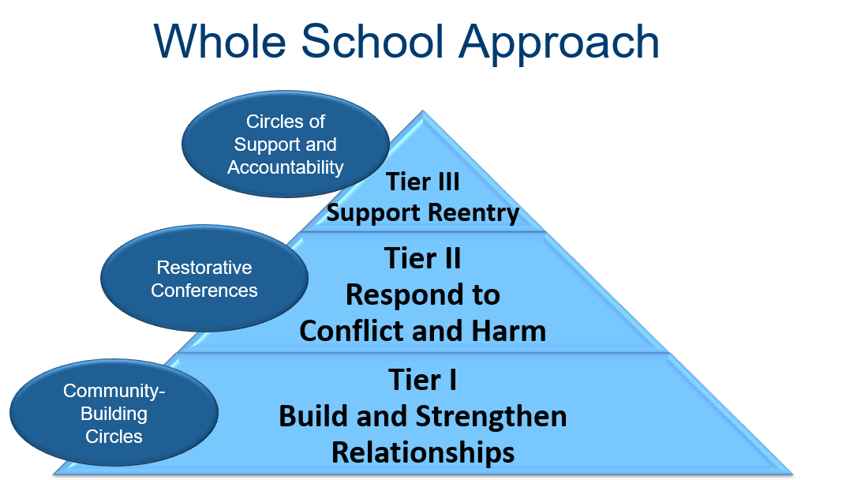

Why should we use it?
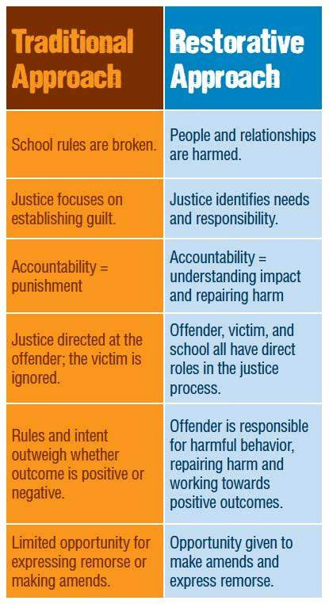

Guide to Restorative Practice

As a standard approach across all WPES settings, restorative practice should be considered for all situations where:

- A pupil / pupils have lost their temper to such an extent in from of others / staff that others have become upset or angry and there are clear indications that the situation is going to continue post original incident
- A pupil / pupils have damaged property of WPES, another pupil or staff member
- Instances of bullying, harassment and / or intimidation
- Clear relationship breakdowns between pupils, pupils and staff, staff and staff
- Situations where pupils have misunderstood the intentions of someone / others which has led to a breakdown in a relationship, friendship or classroom management
- Situations where the actions of someone has caused upset or offence

When to use Restorative Practice?

As a standard approach across all WPES settings, restorative practice should be considered for all situations where:

- A pupil / pupils have lost their temper to such an extent in from of others / staff that others have become upset or angry and there are clear indications that the situation is going to continue post original incident
- A pupil / pupils have damaged property of WPES, another pupil or staff member
- Instances of bullying, harassment and / or intimidation
- Clear relationship breakdowns between pupils, pupils and staff, staff and staff
- Situations where pupils have misunderstood the intentions of someone / others which has led to a breakdown in a relationship, friendship or classroom management
- Situations where the actions of someone has caused upset or offence

Points to remember

- Restorative practice is to be considered as a response and consequence of people’s actions – the focus is the two Rs – Reflect and Repair.
- It is not sensible to attempt to use restorative practice in the immediate aftermath of a situation, when tempers and emotions are high. When emotions have calmed and people feel more settled, there needs to be a commitment and expectation on staff and pupils, that a neutral member of staff will formally undertake a restorative process. This does not have to be a leader – it can be any member of staff that both people / groups deem suitable and appropriate.
- Restorative practice is not about taking sides – it is about getting people involved in a situation to a point of acceptance and acknowledgement of what has happened, the feelings of people, the impact of what has happened and to discuss thoughts on how to repair the situation so that the original situation is less likely to happen again.
- Restorative practice at WPES is to be used as a process – it is not a one-off meeting and then everything returns to normal. It is an entitlement of everyone to be treated with dignity and acceptance and to come together for repeated reviews to assess if the original concern / grievance has been sustainably improved and managed.

The WPES process

When something has occurred or there has been a challenging behaviour incident, once all evidence and incident reports have been collated, an appropriate member of staff needs to plan to convene a Restorative Justice Case Conference. It is at this Case Conference that everyone involved in a situation / incident / event will get the opportunity to have their say.

In advance of the Case Conference, all parties need to be provided with the core RJ questions so that they can think in advance, about how they will answer them:

- What happened and how you became involved?
- What happened next / or what else happened?
- What were you thinking at the time this happened?
- What have your thoughts been since?
- Who has been affected / upset by this and in what way?
- What has been the hardest thing for you?

After ‘wrongdoers’ and ‘harmed persons’, and main witnesses have had their opportunity to speak, the lead member of staff will summarise the main points.

The Lead member of staff will then ask the harmed person(s):

‘What would you like to see come out of this meeting’?

The Lead member of staff will then ask the perpetrator(s):

‘What do you feel needs to happen to put this right’?

It is at this point that a discussion can be had about any reasonable consequences / repair that needs to take place so that the victim(s) feel that justice has been carried out. This consequence could be: write to apologise, purchase new property, repair physical damage, and lose a privilege.

The Lead member of staff will then decide if a Restorative Justice Contract is required between all parties and this will be completed together and signed by everyone.

A review date and time needs to be booked in for a meeting in a week or two, so that the lead member of staff can check that the contract is being honoured.

It is recommended that there are at least two review meetings planned after the main case conference to check that progress has been sustained and that all parties are moving on.

R1 - Restorative Justice Conference Facilitator Script –
Acknowledged Harm/Accepted Responsibility
Step 1 | Welcome, as you know my name is xxxx and I have been asked to facilitate this meeting. (Introduce participants if necessary). I have spoken to all of you about the incident (briefly outline what happened) I remind you that you are here to discuss what happened, not the character of anyone involved. I will invite you all to talk about how you and others may have been affected by what happened. This will help everyone understand what needs to be done to help put things right. I would also like to remind you of the ground rules that we discussed in preparation to ensure that this meeting runs safely and respectfully. Do you remember what we discussed? (If necessary read them out e.g. turn taking, listening to others, not interrupting, no shouting, respect for everyone) Are you still happy to agree to those ground rules?
Step 2 | START WITH WRONGDOER(S) - I would like to start by asking ……….…  Can you tell us about what happened and how you became involved?  If necessary - What happened next and/or what else? (ask this until their story unfolds)  What were you thinking at the time this happened?  What have your thoughts been since?  Who has been affected/upset by this and in what way?  What has been the hardest thing for you?
Step 3 | TURN TO HARMED PERSON(S) - I would like to start by asking ……….…  Can you tell us about what happened and how you became involved?  If necessary - What happened next and/or what else (ask this until their story unfolds)?  What were you thinking at the time this happened?  What have your thoughts been since?  Who has been affected/upset by this and in what way?  What has been the hardest thing for you?
Step 4 | THEN ASK REMAINING PARTICIPANTS IN TURN THE SAME QUESTIONS
Step 5 | GO BACK TO THE WRONGDOER(S) – you have just heard how xxxx and others have been affected by what happened  Do you all see that harm/upset that has been caused?  Is there anything you wish to say at this stage?  Do you think that something needs to be done to repair that harm/put it right and if so what?
Step 6 | GO BACK TO THE HARMED PERSON – What do you think needs to happen?
Step 7 | GO BACK TO THE WRONGDOER(S) – What do you think of what xxxx has suggested?
Step 8 | If necessary - RETURN TO PERSON HARMED AND THEN OTHER SUPPORTERS - What would you like to see come out of today’s meeting?
Step 9 | If necessary - RETURN TO WRONGDOER – Is there anything, you would like to add.
Step 10 | M A K E C O N T R A C T / A G R E E M E N T
Step 11 | OPTIONAL QUESTIONS – Would you do anything differently now? /What other choices could you have made? /What have you learned from the meeting?
Step 12 | FINAL INVITATIONS TO SPEAK – Before I close, the meeting is there anyone else who wishes to say or ask something.
Step 13 | FOLLOW UP – As part of this process you have agreed not only to keep to this contract but to come together to review how the contract is progressing. Thank you for participating in this meeting, I hope that your time together has helped you deal with this matter

R2 – Restorative Chat Preparation Sheet
PREPARATION SHEET - Facilitators Notes: - It will be good to consider - Who has been affected by this behaviour, what are the needs of those affected by this behaviour and how will they be met by the restorative work you are planning?

What happened? Discuss and agree the main issues of the problem and explain to pupils that you will be keeping to those issues in any discussion.

What were you thinking when these things happened?

What do you think about it now were talking?

Who has this affected? Make a list and prompt if necessary (i.e. what about your Mum, what about their Mum, who was there when these things happened, what members of staff have tried to sort it out?

How have the people listed above been affected?

Is there anything you need to take responsibility for, can you see that you added to this in any way? If so what?

What do you think needs to happen to put things right and ensure this does not happen again?

I think it would be a good idea to write a contract between everyone to ensure we all know what is agreed and what needs to happen in the future to ensure that this is resolved and will not happen again. What would you like put on the contract? What do you think others would like put on the contact?

What has been the hardest thing for you?

What could you do differently next time if tensions start to build up?

If we are able to resolve this issue what difference will it make to you coming into school, how you feel about being at school, your studies and what you would like to achieve whilst at school?

If we are unable to resolve this issue what difference will it make to you coming into school, how you feel about being at school, your studies and what you would like to achieve whilst at school?

RS3 – Large Group Restorative Chat Script (Use Preparation Sheet RS3)
Arrange circle depending on what has been said to you in preparation above, ask the person you think will be most honest to your right in the circle, the person who is likely to add positively to what person 1 has said next to them

Ask the questions 1-5 to each participant in turn – say I would like to come back to you (name participant) and ask you….
1. What happened? Discuss and agree the main issues of the problem and explain to pupils that you will be keeping to those issues in any discussion.
2. What were you thinking when these things happened?
3. What do you think about it now were talking?
4. Who has this affected?
5. How have the people listed above been affected?
Ask questions 6 and 7 to everyone at the same time
6. Is there anything you need to take responsibility for, can you see that you added to this in any way? If so what?
7. What do you think needs to happen to put things right and ensure this doesn’t happen again?
Make contract – say I think it would be a good idea to write a contract between everyone to ensure we all know what has been agreed and what needs to happen in the future to ensure that this is resolved and will not happen again. What would you like to be put on the contract? What do you think others would like put on the contact?
Ask the questions 8-11 to each participant in turn – say I would like to come back to you (name participant) and ask you….
8. What has been the hardest thing for you?

9. What could you do differently next time if tensions start to build up?

10. If we are able to resolve this issue what difference will it make to you coming into school, how you feel about being at school, your studies and what you would like to achieve whilst at school?

11. If we are unable to resolve this issue what difference will it make to you coming into school, how you feel about being at school, your studies and what you would like to achieve whilst at school?

R4 Conference Preparation Framework

Give time out to calm down -if needed

Offer re-assurance and support
•"Let's sort this out" or
•if appropriate -"you're not in trouble"

Explain what will happen

Ask Blue Card questions
•Unpick "who's been affected by this"

Consider supplementary questions. See handout i.e.
•Tell me more about that?
•Where were you when this happened?
•What happened before this?

If suitable to conference, discuss and agree:
•Outcomes
•Contract
•Ground Rules
•Confidentiality

Crucial closing points of focus:
Areas for consideration before the conference
Close on a positive note

R5 - Conference Preparation Record Sheet

What happened?

What were you thinking?

What do you think now?

What needs to happen to put this right?

What could you put on the contact?

What could the other person put on the contact?

What has been the hardest thing for you?

What could you do differently next time?

R6 - Restorative Conference Contract/Agreement

Incident date: ……....……….… Conference date: ……..…………………

Description of Incident: …………………………………..………….…………..

Participant 1: ……………….……………..……..……………………….

Participant 2: ……………….……………..……..……………………….

Participant 3: …………….………………..……..……………………….

Participant 4: …………………..………………………………………….

We have agreed the following:
1.

2.

3.

4.

5.

6.

7.

Signed by participants: ……...……………………………..………..……………….
………………………………………..…..…………….……
…………………………………………………..……………
………………………………………………..………………

Date for follow up: ……………………………………

R7 - Restorative Language for Circles

Check-in
At the beginning of the day or class, have an opening circle where everyone one has the opportunity to tell the circle something about their day so far. Questions to start check-in could be:
• Say something positive about your …. Dog/cat/weekend/evening/holiday?
• What do you need to do to be a better learner?
• What are you looking forward to today?
• If you were a superhero what power would you have?
• Say something positive about yourself.

• always try to add “and how are you feeling”?

Checkout
At the end of a day or a class, have a closing circle where everyone one has the opportunity to tell the circle something about their day. Questions to start checkout could be:
• How was your day?
• Tell us one thing you liked about this school today.
• Tell us one thing you learnt today.
• What are you going to differently tomorrow?

• Always try to add, “How did you feel about that”?

Aim for Lesson/Today/Week
Once your pupils are practiced at checking in and out it is possible to use the time to create an aim for the less/day/week. This is meant to be a small achievable change of behaviour that reinforces the idea that pupils have the skills to be able to change and regulate their own behaviour.
• What is one thing you would like to achieve?
• What is the one thing you would like to change?
• What do you need to achieve your aim?

Monitoring
• What did you achieve this lesson/today/week?
• What thing did you manage to change this lesson/today/week?
• What do you need to do to make sure you achieve your goals tomorrow?
• Who is someone in this class who worked hard this week?
• What is the most useful thing you have learned.
• Say someone who helped you.
• What is something you know that you did not know how yesterday?

Resolving Conflict- Both Parties
• What happened?
• What were you thinking of at the time?
• What have you thought about since?
• Who has been affected by what you have done? In what way have they been affected?
• What do you think you need to do to make things right?

Affective Statements
• It makes me uncomfortable when I hear you teasing xxx.
• I am frustrated that you are not listening to me.
• I feel sad when you say something like that to xxx.
• I get angry when you talk and joke during my lessons.
• I was upset to see you hurt xxx.

Classroom Norms/Learning Agreements
Classroom norms give pupils the opportunity to think about how they need to behave to be able to achieve their aims for the year. Creating norms also creates the opportunity to think about what they need from other people to be able to work at their best and what other people need from them in return. Once pupils have taken time and effort to create a list of rules or expectations it creates ownership of good behaviour as the rules are not imposed but created by themselves. Classrooms norms should be discussed and agreed whilst in a circle. Here are some questions that may help beginning the circle.
• What do you need to do to be able to learn while you are in class?
• How can we avoid the things that make learning difficult for you.
• What can we agree on to ensure we will all behave positively and treat each other with respect?
• What could we do if someone breaks the rules?

Circles to Address Behaviour Problems
During circles for addressing behaviour problems, the restorative questions listed earlier can be used, but a variety of other questions may be helpful. It may be necessary to speak to the class first to set ground rules.
• What will make the circle safe for everyone?
• What do you hope the circle will achieve?
• How can we ensure we meet our aims?
• What was your part/responsibility in the problem?
• What needs to happen to put this right?
• What can we do to make sure this doesn't happen again?
• What could we put on a contract to ensure that this doesn’t happen again?

R8 - Examples of Restorative Scripts

There are many restorative scripts that can be useful to ensure that everyone involved in harm is heard and everything that needs to be done to repair a situation happens. It may be useful to decide discuss with staff when individual scripts will be most useful or ask staff to devise their own.

Main Restorative Script

What happened?
What were you thinking of at the time?
What have you thought about since?
Who do you think has been affected by what you did and in what way?

Alternative Restorative Scripts

What's happened?
Who’s been upset by this?
What needs to happen to put things right?
What could you have done differently?
What's happened?
What choice did you make?
What choice could you have made?
How can you put this right?
What's happened?
What were you thinking?
What needs to happen to put things right?
What are you going to do differently next time?
What do need to do to make things right?
How can we make sure this does not happen again?
What can I do to help you?
How can we make sure this does not happen again?
Was it the right thing or the wrong thing to do?
Was it fair or unfair?
What exactly are you sorry for?
What's happened?
Who’s been affected?
How can we move forward?
How can we do things differently in future?

R9 - Possible Implementation of Restorative Language

1. Everyone needs to engage
2. Staff to model the new approach to pupils
3. Staff to have time to prepare the use of new language
4. Staff using the language consistently makes it safe for everyone
5. Staff to use new language fluently
6. Staff to be self-aware about their use of language and its impact
7. Develop and expert group to champion it use
8. NQT training to include restorative language

How Pupils Could Help Implement RA

1. Ask the pupils how to implement it
2. Praise students when they use it
3. Encourage students to use restorative language
4. Peer mentoring scheme to use restorative language
5. Peer conference facilitator scheme
6. Peer mediator scheme
7. Introduce into sports i.e. how you talk to the referee
8. Discuss each term in tutor time
9. Role play in tutor time, drama, assemblies

How RA Could Be Introduced Into Teaching

1. Restorative Merit Scheme
2. Introduce restorative circle time
3. Use of restorative keywords by staff
4. Key word for the day
5. Use RL in word of the week
6. Build into curriculum
7. Introduce in PSD, PHSE, CPD
8. Introduce into Citizenship
9. Include restorative language examples into homework / planning books
10. To be included in learning objectives
11. Create clear understandings of the vocabulary
12. Dedicated lessons to teach and implement it
13. Use tutor time to look at scenarios and open question practice sessions
14. To be included in personal goals
15. Art displays on wall
16. Assemblies to introduce RA/RJ
17. Use within the curriculum in similar way to SEAL
18. Include into lesson objectives

