Future
Building
Staff Guide

There is a bright future ahead of you.
You are capable of many things and you can achieve and be successful.
You are important and you deserve the very best in life.
You can be in school every day and on time – you can do this!

Contents
Focus | Page
The purpose of this programme | 4
SESSION 1  - School Attendance – the building blocks to a bright future  - What I want to achieve with my life | 6
SESSION 2  - Where I am right not on my journey to my bright future | 7
SESSION 3  - How I am going to get to where I want to be  - What support and help I need to remove any barriers | 8
SESSION 4  - Why good school attendance makes a difference to my future  - What support and help I need to remove any barriers | 9
SESSION 5
- Planning for change and tracking change
ONGOING and from start of programme  - My attendance and punctuality log | 10

The purpose of this programme
We want all our children and young people to attend highly and at least 95% of the time. High attendance builds futures and secures higher educational outcomes and improved life chances. We need children in school, every day and on time. Our children are safer when they are in school.
The Future Building Programme supports our trauma-informed approach, grounded in relationships and our ambition to show curiosity towards our children, their needs, their background and their presenting behaviours. Low attendance and poor punctuality are symptomatic of an underlying problem. This programme is designed to unpick the problem and the causes of low attendance and poor punctuality and then to support children in finding solutions. We therefore build greater self-awareness in our children and also personal resilience.

We follow the Public Health Model:
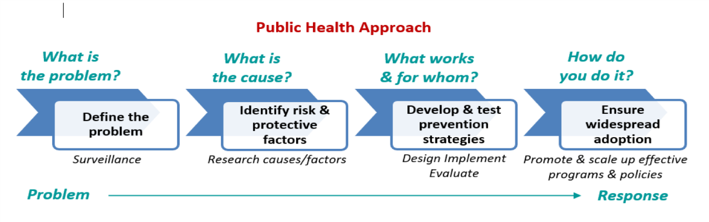
Low attendance and poor punctuality is not what we need to crack. We need to crack the causes and the underlying problem:

- Being criminally or sexually groomed / exploited
- Staying up too late
- Anxiety
- Friendship issues
- Gang-related issues
- Post-code issues
- Transport issues
- Family breakdown
- Caring responsibilities
- Mental Health
- Curriculum uninspiring
- Work too easy / too hard
- Learning need undiagnosed / unmet

The above list is not exhaustive.

Relationships matter to our children. This programme should be delivered in the spirit of support and care; not punishment or retribution.

The goal is simple – to achieve improved attendance and punctuality.

There is an accompanying POWERPOINT PRESENTATION that accompanies the pupil workbook and this staff guide.

SESSION 1 - School Attendance – the building blocks to a bright future

- Present the session 1 powerpoint slides to the pupil(s) and discuss together the many obvious and not so obvious reasons why high school attendance really makes a difference. Make it very clear that attendance below 90% will not support a pupil going back to a mainstream school.

- Expect to hear comments such as: SO WHAT?!; I DON’T CARE; IT’S TOO LATE FOR ME NOW!

- Discuss healthy habits and simple strategies that help people get into school every day and on time.

- Start the discussion about FUTURE PLANNING and what the pupil(s) want to achieve as they grow up. Expect some blank faces and ‘I DON’T KNOW RESPONSES’ here. Encourage thinking and support ideas using your knowledge of the pupil and their interests. It is fine for their to be some blank parts of the pupil workbook here as you can also return to this section later.

- Encourage pupils to focus their ideas on:

- Qualifications / education / training
- University
- Employment
- Their desired ‘salary’ and ‘earning potential’
- Their wishes for a home, family and the objects and items that they feel will make their life meaningful, happy and worthwhile
- Experiences they may wish to have

SESSION 2 - Where I am right now on my journey to my bright future

It is important to assesss and acknowledge the starting point for a pupil(s)’ attendance before we start planning for improvements. We also need to acknowledge and know about any barriers and the causes of the low attendance and poor punctuality.
- Show the pupil their up-to-date attendance certificate, getting them to find their current school attendance percentage and count up the number of late marks since September. Get them to note this down in the pupil workbook.

- Show the powerpoint slides for SESSION 2, focusing on the causes of low attendance and poor punctuality and have a discussion around which of these causes / barriers apply to the pupil(s).

- Get the pupils to talk openly and then get them to note these causes / barriers down in the pupil workbook; reflecting on and noting also the reason why each issue / barrier actually prevents good attendance / punctuality

SESSION 3 - How I am going to get to where I want to be

Before showing the powerpoint slides for SESSION 3:
- Refresh the pupil(s) thinking about the causes of low attendance the barriers they identifed during session 2.

- Discuss if the pupil(s) have given any thought to what they or others could do to help remove the problem(s) or barrier.

Talk through the powerpoint slides for SESSION 3:
- Discuss solutions to the problems / barriers identified in SESSION 2. Encourage deep thinking and reflection here.

- If some of the barriers / causes relate to boredom or no interest in the curriculum, it is important to focus on WHAT COULD WE DO TO SUPPORT YOU WITH THIS? WHAT DO YOU WANT TO DO? – Make sure you report back this to the Head of Centre / Assistant Head so that consideration can be given to a personalised curriculum / timetable.

- Support the pupil(s) in noting down the solutions to the problems and causes of low attendance and poor punctuality

Go back to the notes made from SESSION 1 about ambitions for the future, aged 16, 18, 21 and 30 and refresh the pupil(s) memory of these plans.

- Show the next powerpoint slides as part of SESSION 3 focusing on what action the pupil(s) need to take to achieve their goals.

- After discussion, encouragement and support, talk the pupil(s) through their ideas for what action they need to take to achieve their goals / wishes / dreams and get them to note these down in the pupil workbook.
SESSION 4 – Why good school attendance is important to my future
What support and help I need to remove any barriers

Go back over SESSION 1 and WHY good attendance and punctuality are important and make a difference to their future.
- Show the first slides from SESSION 4 which go over further reasons WHY good school attendance and punctuality are important.

Refresh the pupil(s) memory of the discussion during SESSION 2 and 3 about the causes of their low attendance / poor punctuality and the action they feel they need to take to achieve their goals.
- Show and discuss the SESSION 4 powerpoint slides focused on support networks and what / who can help the pupil(s) remove the barriers to good attendance and poor punctuality.

- Get the pupil(s) to consider which ones of these ‘supports’ could be of help to them; can they think of any more?

- Get the pupil(s) to note down WHAT SUPPORT THEY NEED and WHY THIS WILL HELP THEM in the pupil workbook

- At some point after this session – share this with the Head of Centre / Assistant Head so that they can look into ensuring any support is put in place for the pupil / family.

SESSION 5 - Planning for change and tracking change
Start by pulling together everything that has been discussed so far during the programme.

Show the powerpoint slides for SESSION 5, focusing on target setting and how improvements will be tracked:
- Support the pupil in understanding how to work out targets by certain dates using the appendix at the back of this staff guide.

- Support the pupil in thinking in 2 week blocks when setting targets for future improvements in attendance.

- Get the pupil to work out ambitious but reasonable targets and note these down for at least the next two months.

Pupils need to be met at least weekly to go over what was discussed in this programme and to check on attendance and punctuality compared to the targets set. The follow-up weekly meetings also need to focus on:

- Updates on whether problems / barriers are being removed or reduced
- Whether the support identified is being offered and put in place

