Future
Building

NAME: ____________________________________________
CENTRE ___________________________________________
There is a bright future ahead of you.
You are capable of many things and you can achieve and be successful.
You are important and you deserve the very best in life.
You can be in school every day and on time – you can do this!

Contents
Focus | Page
School Attendance – the building blocks to a bright future | 4
What I want to achieve with my life | 6
Where I am right not on my journey to my bright future | 7
How I am going to get to where I want to be | 9
What support and help I need to remove any barriers | 12
Why good school attendance makes a difference to my future | 14
Planning for change and tracking change | 16
My attendance and punctuality log | 17

School Attendance – the building blocks to a bright future
There are some undeniable facts about children who have good school attendance:

Attendance over 95% (missing no more than 10 days per year) means better examination results

Attendance over 95% means having the best choice of college placements at age 16
Attendance over 95% means getting a better paid job when you finish college / university. Children with good school attendance can earn 100% more than a child with low attendance
Children who maintain attendance at 95% or over end up with the better jobs, more money, better health, their own home and better life chances

7 ways you can help yourself get into school every day

- Set your alarm each night to allow for plenty of time to get ready. Leave extra time for any unexpected delays

- Prepare for the morning the night before. Lay out clothes, be sure bags are ready to go.

- Make sure you have a backup plan in place for if your normal transport plan falls through.

- Establish a bedtime routine that ensures a restful night.

- Check the weather and plan.

- Keep the television turned off on school mornings and avoid other distractions that can take away from your routine.

- Save time in the morning by having a bathe or shower before bed.

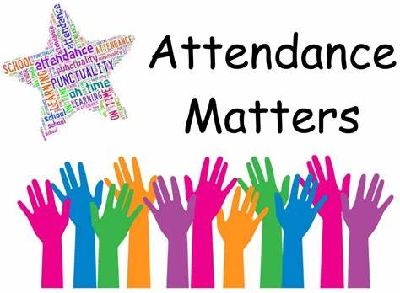

What I want to achieve with my life

At the age of 16, I want to have achieved:

At the age of 18, I want to have achieved:

At the age of 21, I want to have achieved:

At the age of 30, I want to have achieved:

Where I am right now on my journey to my bright future

My current school attendance since September and my current number of late marks:
Current attendance | Current late marks

If I took no more days off school between now and the end of July, my school attendance could get to:
Attendance at end of July if I took no more time off school

What is stopping you from getting into school every day and on time?
What is stopping me? | Why does this stop me attending school?
What is stopping me? | Why does this stop me attending school?

How I am going to get to where I want to be

Firstly, what can we do about the things that stop you from attending school?

Barrier | What is the solution to this?

Now think about your plans for age 16:
What action do I need to take to help to get to this point?
1
2
3
4

Now think about your plans for age 18:
What action do I need to take to help to get to this point?
1
2
3
4

Now think about your plans for age 21:
What action do I need to take to help to get to this point?
1
2
3
4

Now think about your plans for age 30:
What action do I need to take to help to get to this point?
1
2
3
4

What support and help I need to remove any barriers
There is a wide network of support around you that can help get you into school more.
CLASS TEACHER | SCHOOL MENTOR
HEAD OF CENTRE | TEACHING ASSISTANT
FAMILY | FRIENDS
MATES team | TRANSPORT

What support do you need to help improve your school attendance?

What I need | This will help me because…….

Why good school attendance makes a difference to my future
We know that you know that good school attendance will make a huge difference to your future, to your life chances and to the money you will earn.

High attenders can earn over £3 million in their working life

High attenders could have £31,000 more disposable income to spend per year than a low attender

High attenders will be able to give their own children better opportunities

Why attending school at 95% or over is important to me and my future:

Getting into school more and on time will help me because:

1
2
3
4
5
6
7
8

Planning for change and tracking change

To reach my future goals and ambitions, I will not commit to get into school more.

Targets I will work hard to achieve:

By _______________________, I will achieve the following attendance
Target % | This means not taking any more than these days off

By _______________________, I will achieve the following attendance
Target % | This means not taking any more than these days off

By _______________________, I will achieve the following attendance
Target % | This means not taking any more than these days off

By _______________________, I will achieve the following attendance
Target % | This means not taking any more than these days off

My end goal for attendance is _______% by __________________________.
My attendance and punctuality log

Date | Attendance since September | Lates since September
How I feel about this
Date | Attendance since September | Lates since September
How I feel about this
Date | Attendance since September | Lates since September
How I feel about this
Date | Attendance since September | Lates since September
How I feel about this

Date | Attendance since September | Lates since September
How I feel about this
Date | Attendance since September | Lates since September
How I feel about this
Date | Attendance since September | Lates since September
How I feel about this
Date | Attendance since September | Lates since September
How I feel about this

Date | Attendance since September | Lates since September
How I feel about this
Date | Attendance since September | Lates since September
How I feel about this
Date | Attendance since September | Lates since September
How I feel about this
Date | Attendance since September | Lates since September
How I feel about this

