Developing senior leadership that has REAL impact

High-Performance Leadership

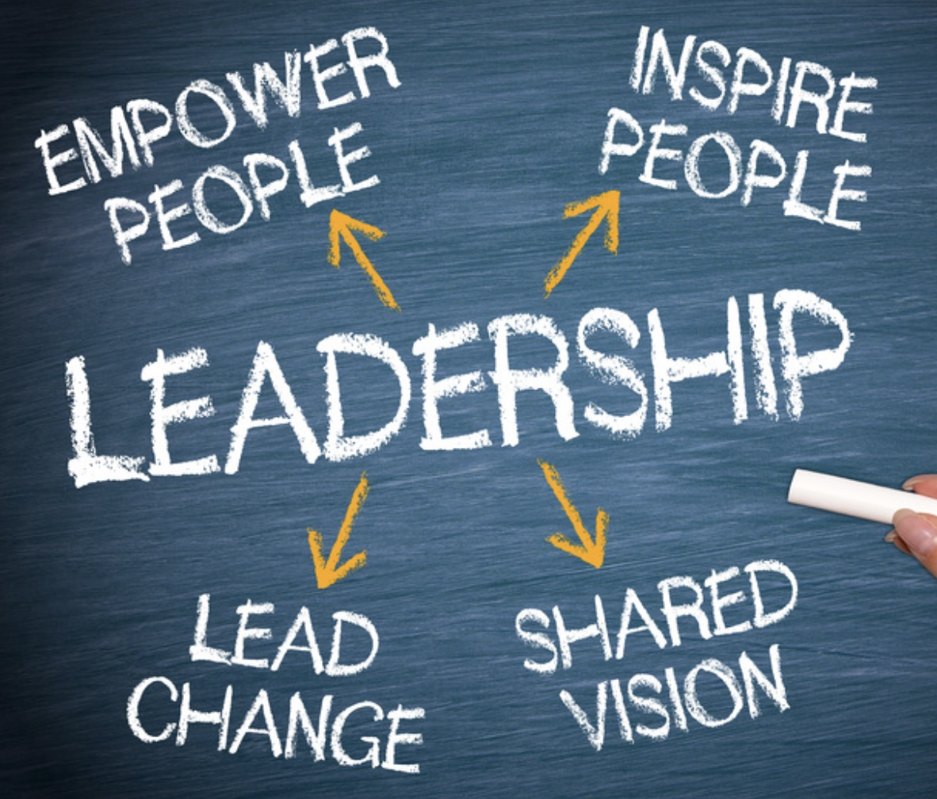
A leadership development programme for SLTs and individual senior leaders within the Hounslow Education Partnership

“This programme has opened my eyes and built my confidence around a sustainable framework for continual school improvement. It really has been outstanding”.
Mr A Lewis - Head Teacher (Wiltshire)

A high-impact leadership programme that focuses on how senior leaders create a culture of continuous improvement by designing and implementing rigorous systems and processes that increase capacity.

This programme will support senior leaders in developing a collective knowledge and understanding around:
- the 4 main influences on the success of any school
- the features of an outstanding leadership team
- essential leadership practices for success
- a range of leadership tools for embedding a strong professional culture
- how to measure impact of what matters
and many more key issues around future school improvement

‘I have genuinely found this programme to be the best leadership development that I have ever experienced. It has always been thought-provoking and challenging, leading me to make significant changes, across the school, which are already having a significant impact’.
N.Sansom - Head Teacher (Havering)

